**3. Serverless Data Processing Pipeline**

**Steps**

1. **Created two S3 bucket one for storage with new folder and one for backup with enabling public access.**
2. **Now created new Lambda function using lab role**
3. **Create S3 bucket trigger. Here prefix is folder name and suffix is file extension**
4. **Write a code.**
   1. **To trigger s3 bucket that when any file uploaded to a particular bucket it’s copy will be saved in another bucket.**
   2. **Also, capitalized data in the file and saved that file with updated name to the original bucket (1’st bucket)**
5. **Upload file to bucket.**
6. **Monitor CloudWatch through log groups**

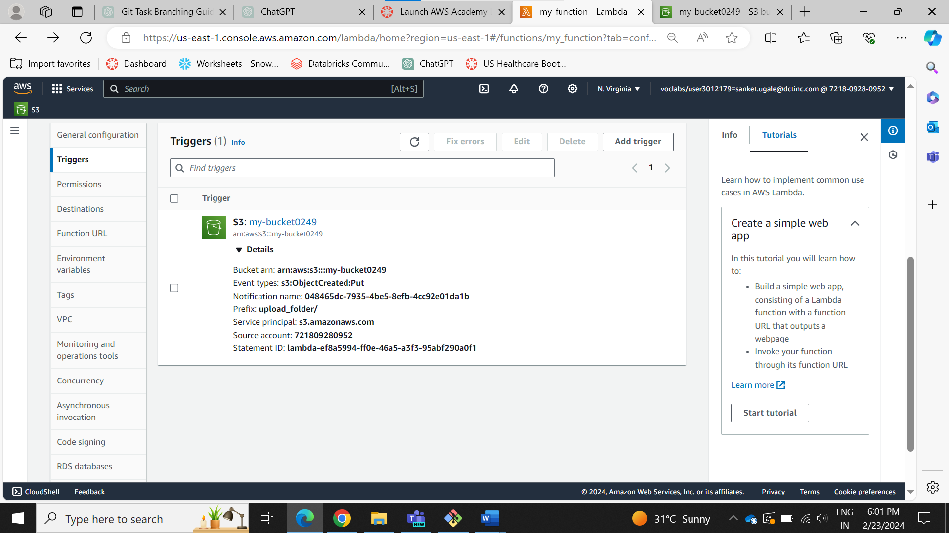

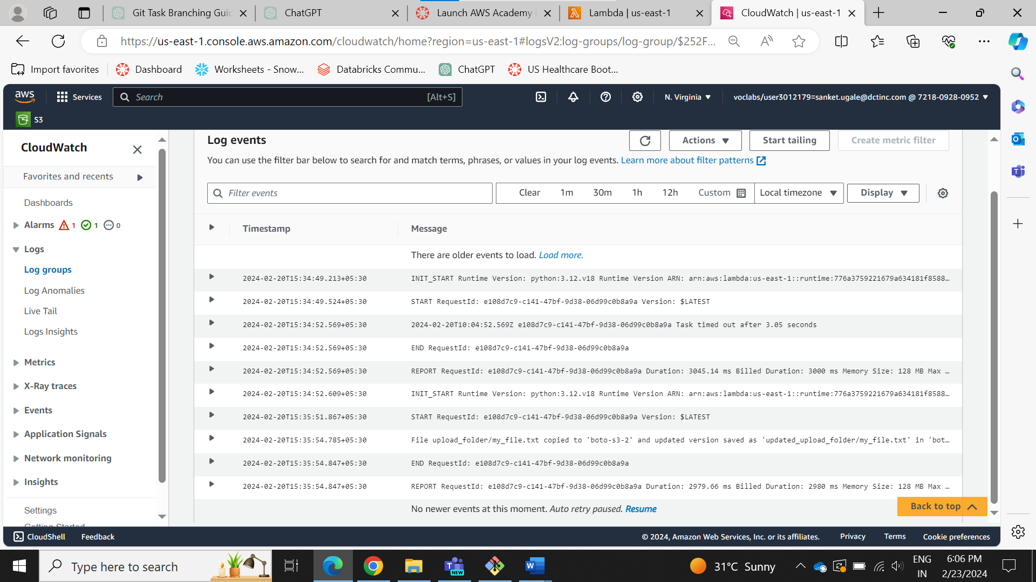

1. **Creating a Serverless API**

**Steps**

1. **Create 4 lambda functions.**
   1. **Get**
   2. **Put**
   3. **Delete**
   4. **Post**
2. **Modify Code**
3. **Create Rest API**
4. **Create Resource**
5. **Create Method for every function.**
6. **Test every method**
7. **Deploy them**
8. A screenshot of a computer

   Description automatically generated**For verification use invoke URL**

